Battle of Britain Living History Show 2012
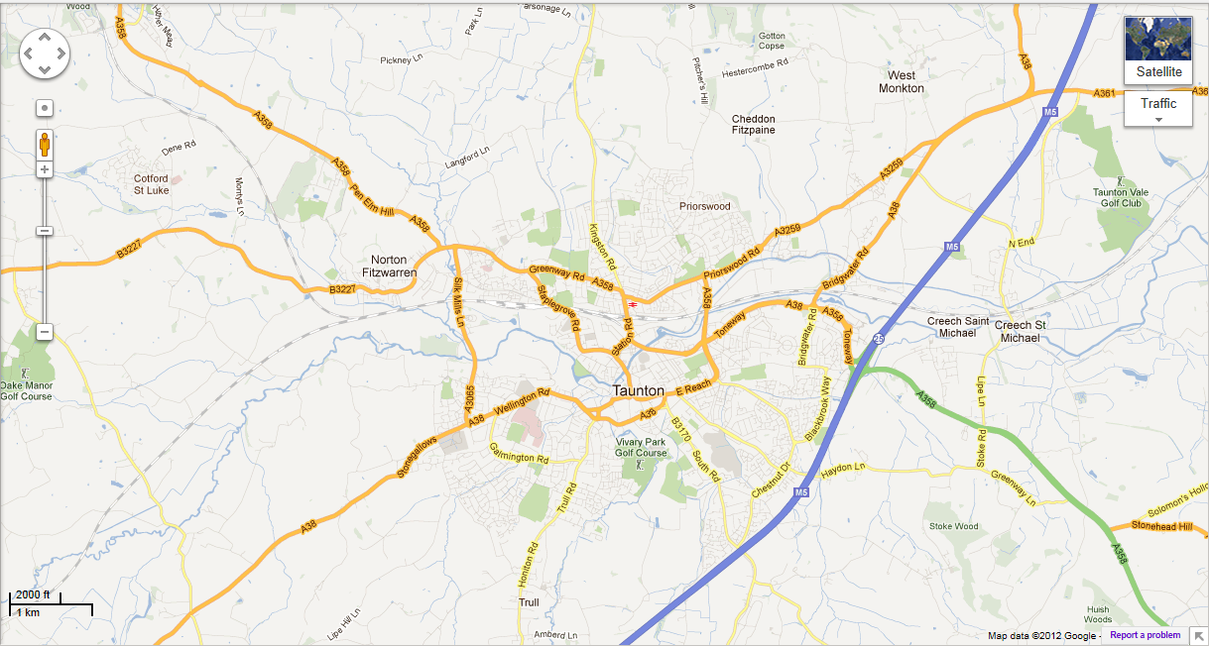
How to Find Us
WE ARE HERE

WSRA FIELDS, NORTON FITZWARREN, TAUNTON, SOMERSET, TA4 1BH
DIRECTIONS FROM M5 J25: Follow the A358 signposted towards Minehead. At the Cross Keys Roundabout (Cross Keys pub on the right) take the B3227 signposted towards Milverton. Pass through Norton Fitzwarren village and turn left immediately past the railway bridge. The showground entrance is on the left a short distance along this road.
Grid Ref: 318562, 125604

